Assignment:
Tasks to Complete:
1. Setup Tomcat
* Download and install Apache Tomcat.
* Start the Tomcat server.
* Verify Tomcat is running by opening http://localhost:8080 in your browser.
2. Build the Application (Maven)
* Open your terminal and navigate to your sample Java web project. (If you don't have one, generate a basic one using Maven).
* Run the Maven command to package the application (e.g., mvn clean package).
* Locate the generated .war file in the target/ directory.
3. Deploy the Application
* Copy the .war file.
* Paste the .war file into Tomcat's webapps folder.
4. Verify the Deployment
* Wait a few seconds for Tomcat to unpack and deploy the application.
* Open your web browser and navigate to your application's URL (e.g., http://localhost:8080/your-app-name).
* Confirm the application page loads successfully.

To prove you completed the task, please provide the following screenshots:
Screenshot 1: Your terminal showing the Maven "BUILD SUCCESS" message.
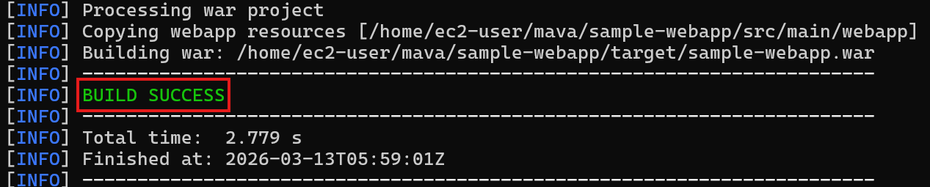
Screenshot 2: Your web browser showing the application running successfully on localhost.
